Evaluation: Random Forest
Accuracy: 0.9676
Precision: 0.9676436053878198
Recall: 0.9676
F1 Score: 0.9675847785889219
Jaccard Index: 0.9379061615863846
Matthews CorrCoef: 0.959518422930582
Cohen’s Kappa: 0.9595
Specificity: 0.9919
AUC: 0.9981180000000001
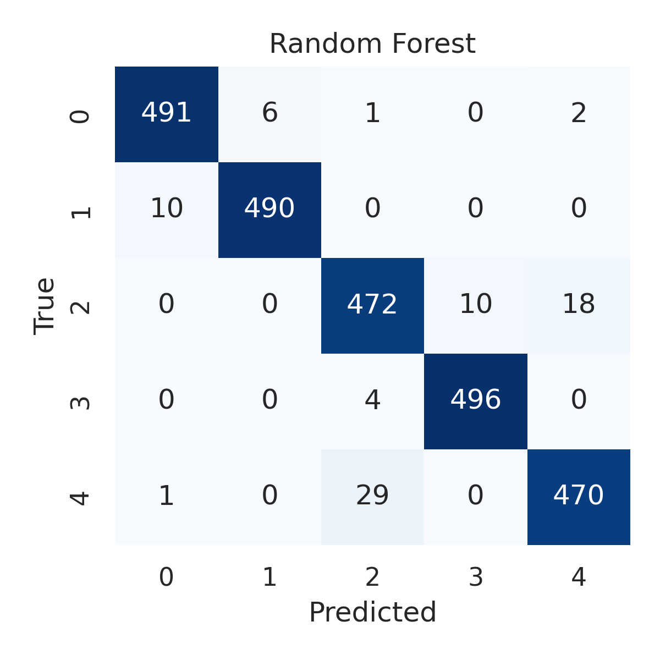

Combined ROC Curves
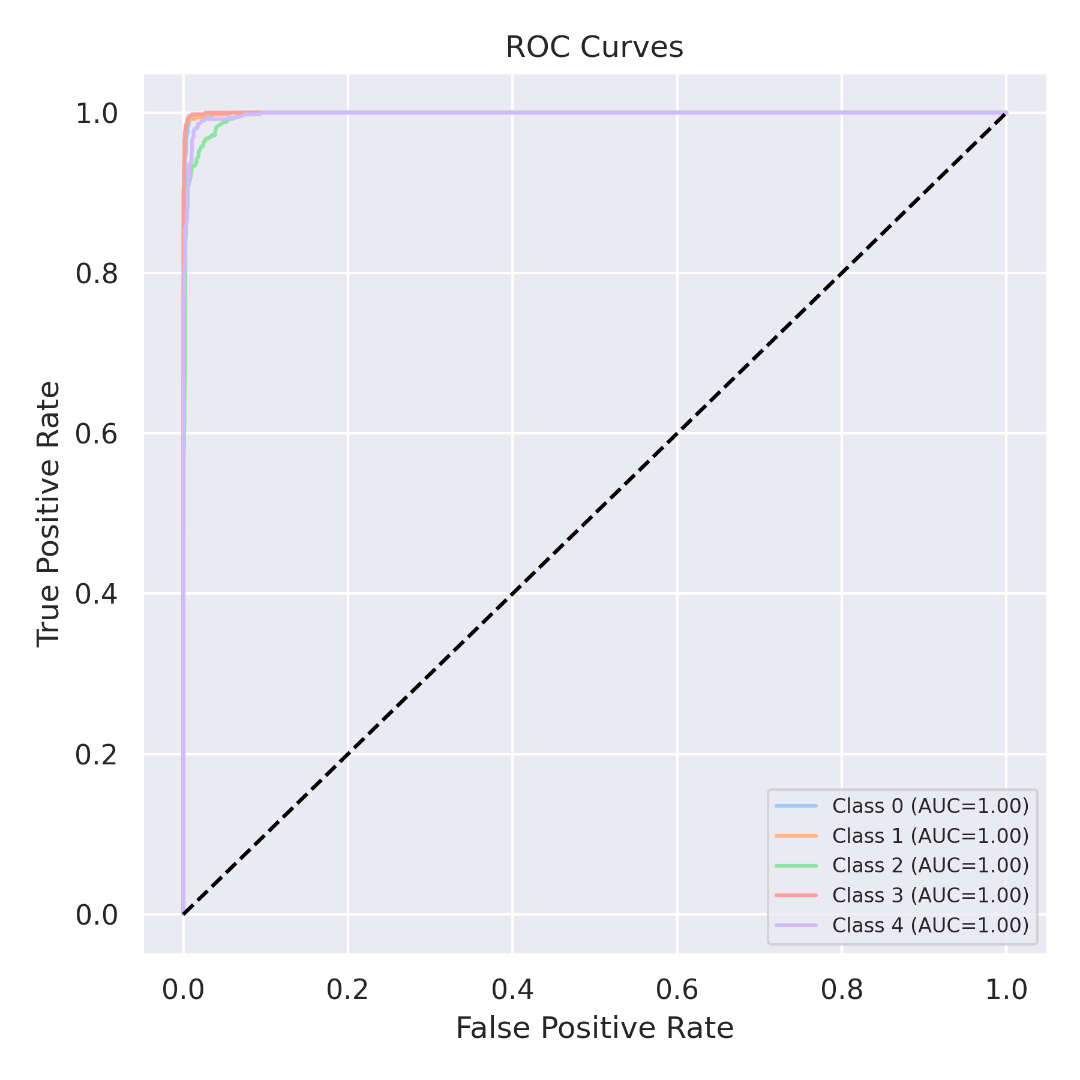

Evaluation: K-Nearest Neighbors
Accuracy: 0.8892
Precision: 0.8915503797607013
Recall: 0.8892
F1 Score: 0.8884207979467057
Jaccard Index: 0.8009378660796694
Matthews CorrCoef: 0.862414298843487
Cohen’s Kappa: 0.8614999999999999
Specificity: 0.9723
AUC: 0.9832365
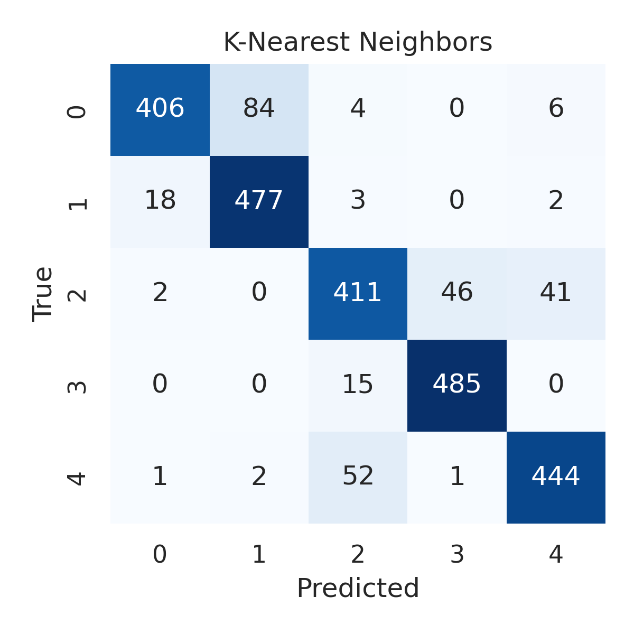

Combined ROC Curves
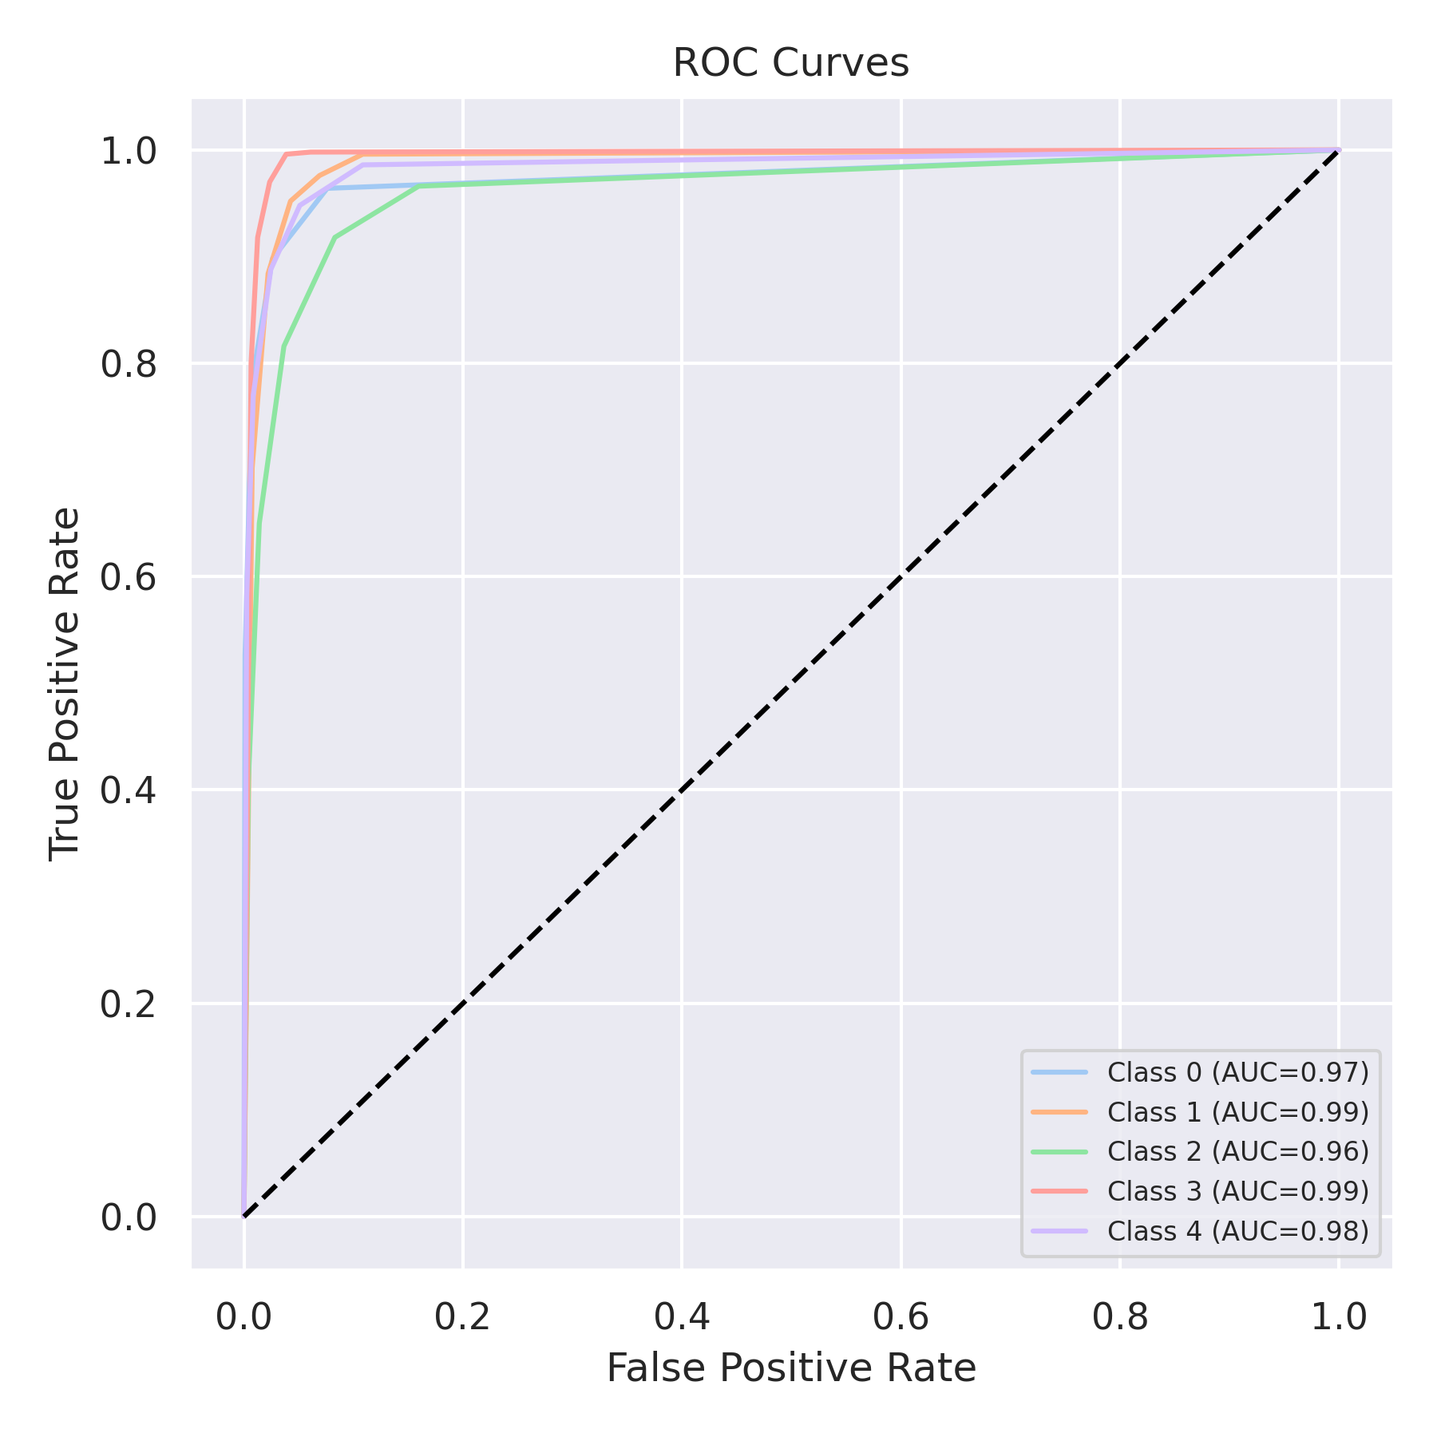

Evaluation: Decision Tree
Accuracy: 0.96
Precision: 0.9601846525293671
Recall: 0.96
F1 Score: 0.9600548263338442
Jaccard Index: 0.9236522377715927
Matthews CorrCoef: 0.9500186205474459
Cohen’s Kappa: 0.95
Specificity: 0.99
AUC: 0.96825
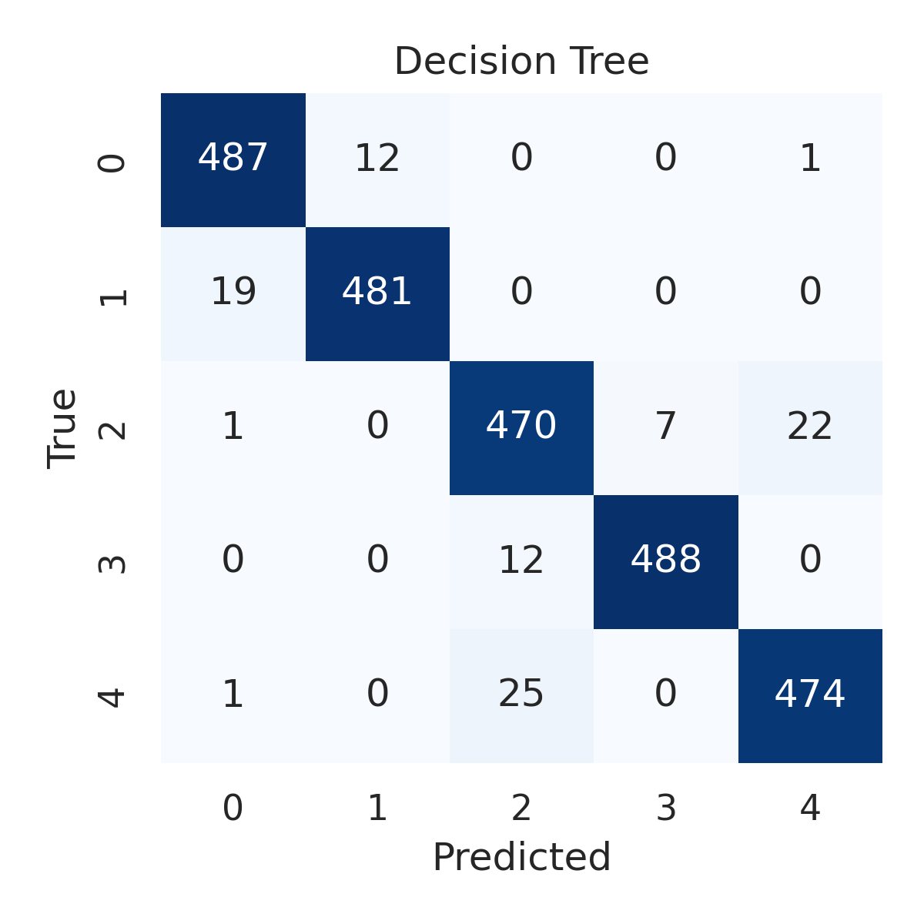

Combined ROC Curves
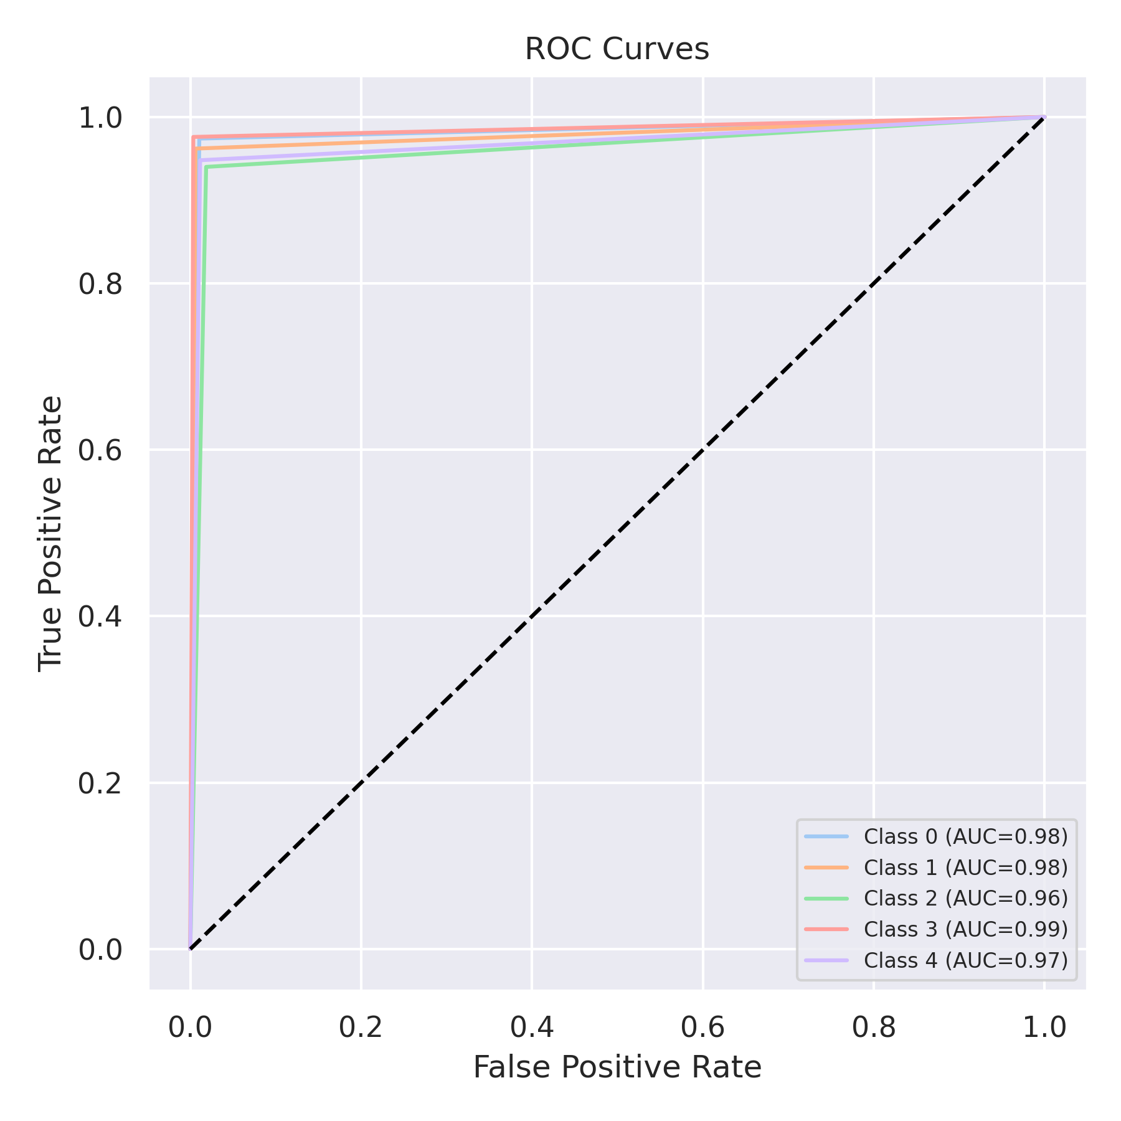

Evaluation: Extra Trees
Accuracy: 0.968
Precision: 0.9679329817423579
Recall: 0.968
F1 Score: 0.9679198997280193
Jaccard Index: 0.9385709606052249
Matthews CorrCoef: 0.9600232328433556
Cohen’s Kappa: 0.96
Specificity: 0.992
AUC: 0.998389
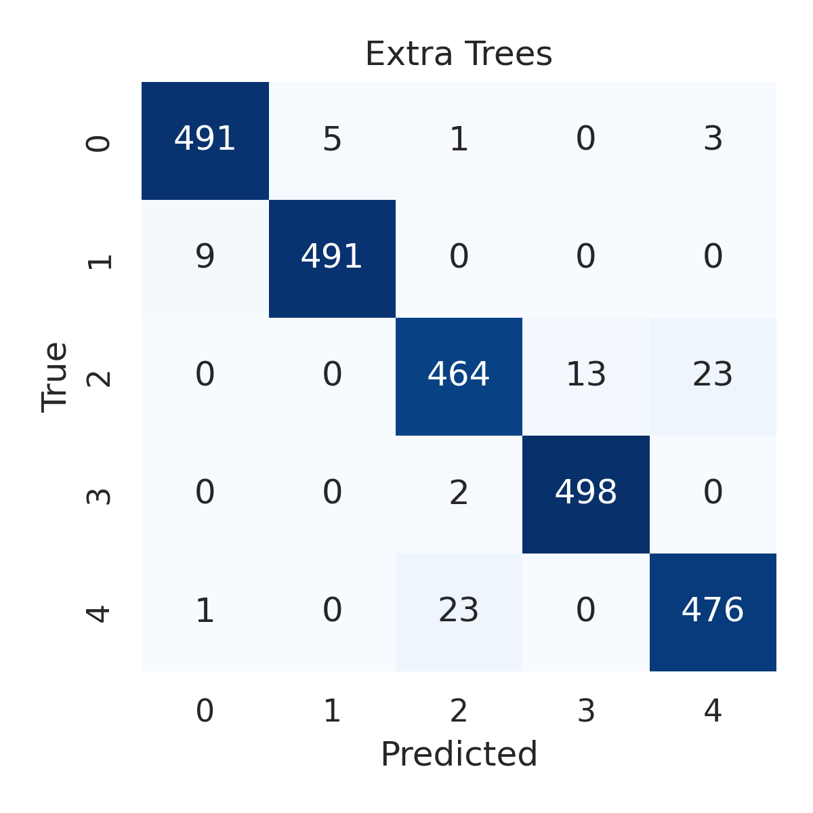

Combined ROC Curves
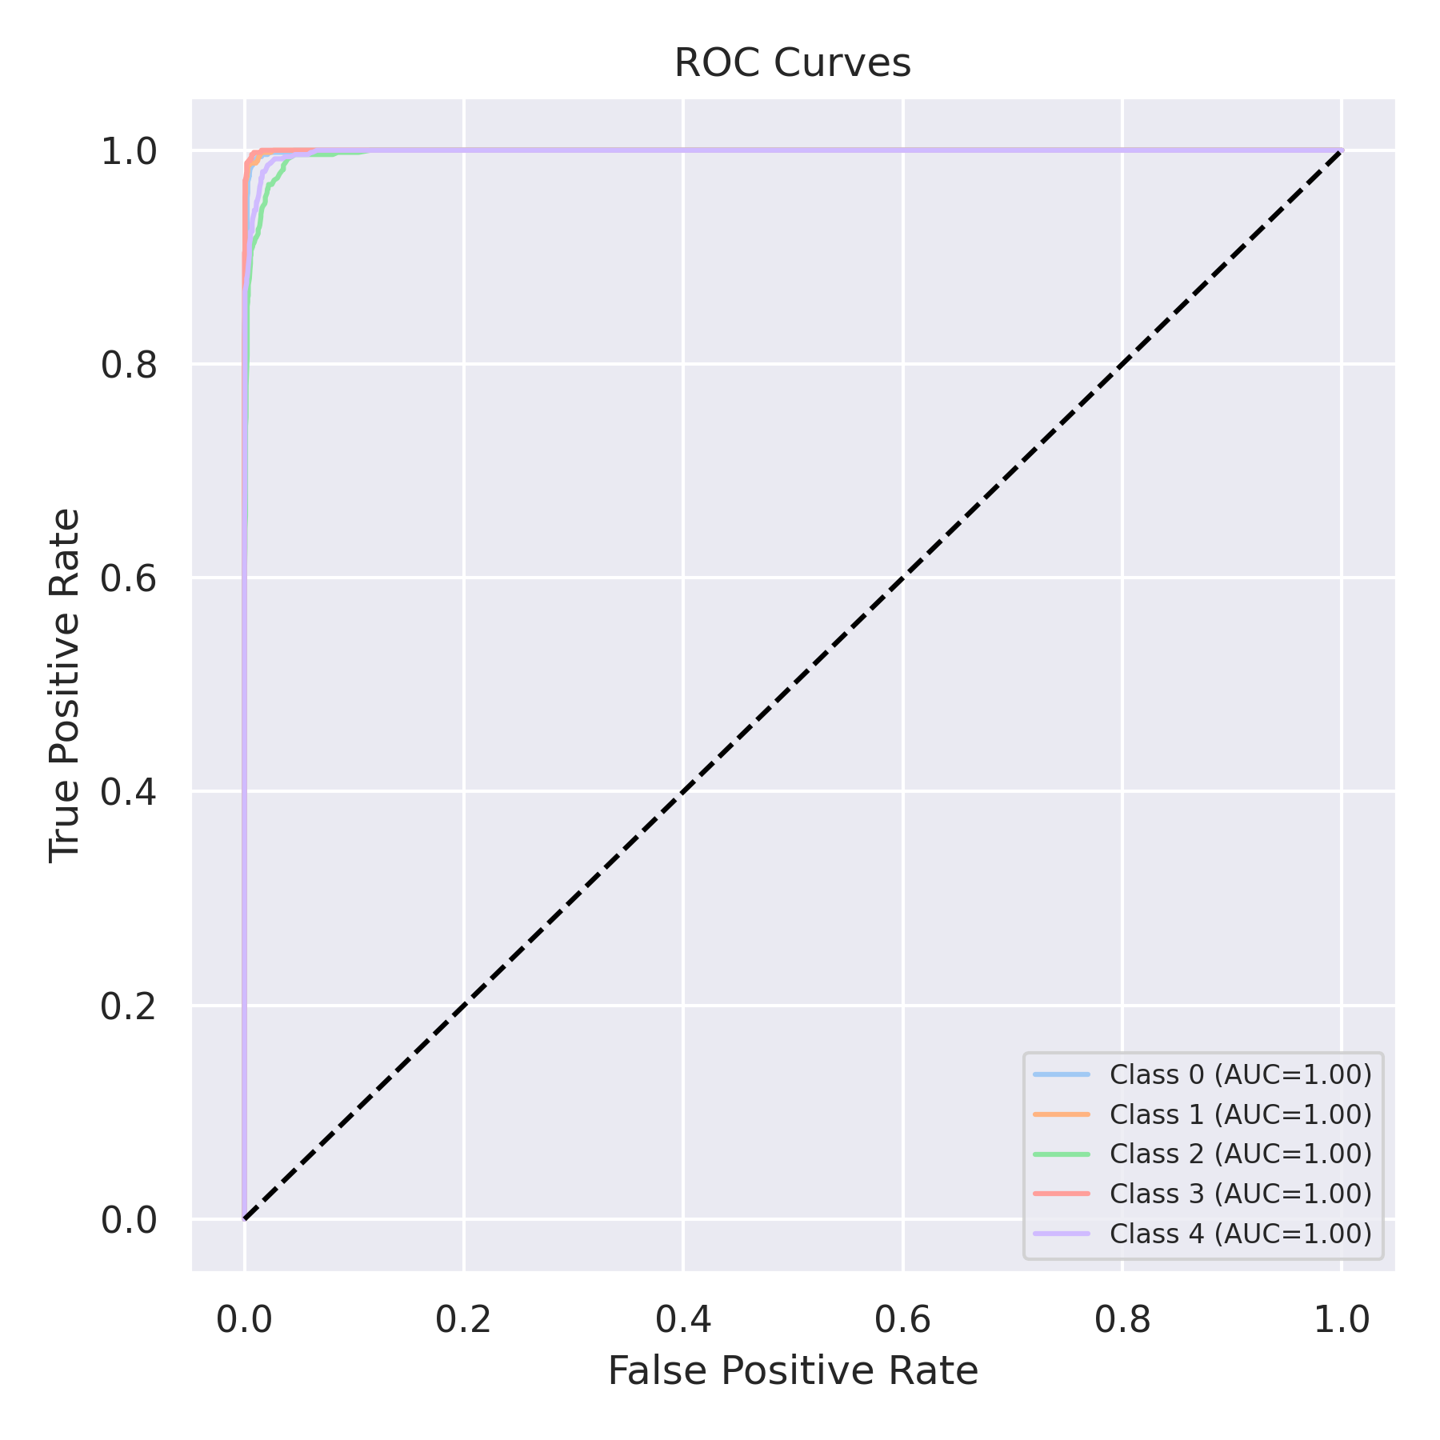

Evaluation: Bagging Classifier
Accuracy: 0.974
Precision: 0.9743093184789888
Recall: 0.974
F1 Score: 0.9740296400095071
Jaccard Index: 0.9500359439345133
Matthews CorrCoef: 0.9675634742459341
Cohen’s Kappa: 0.9675
Specificity: 0.9934999999999998
AUC: 0.9947195
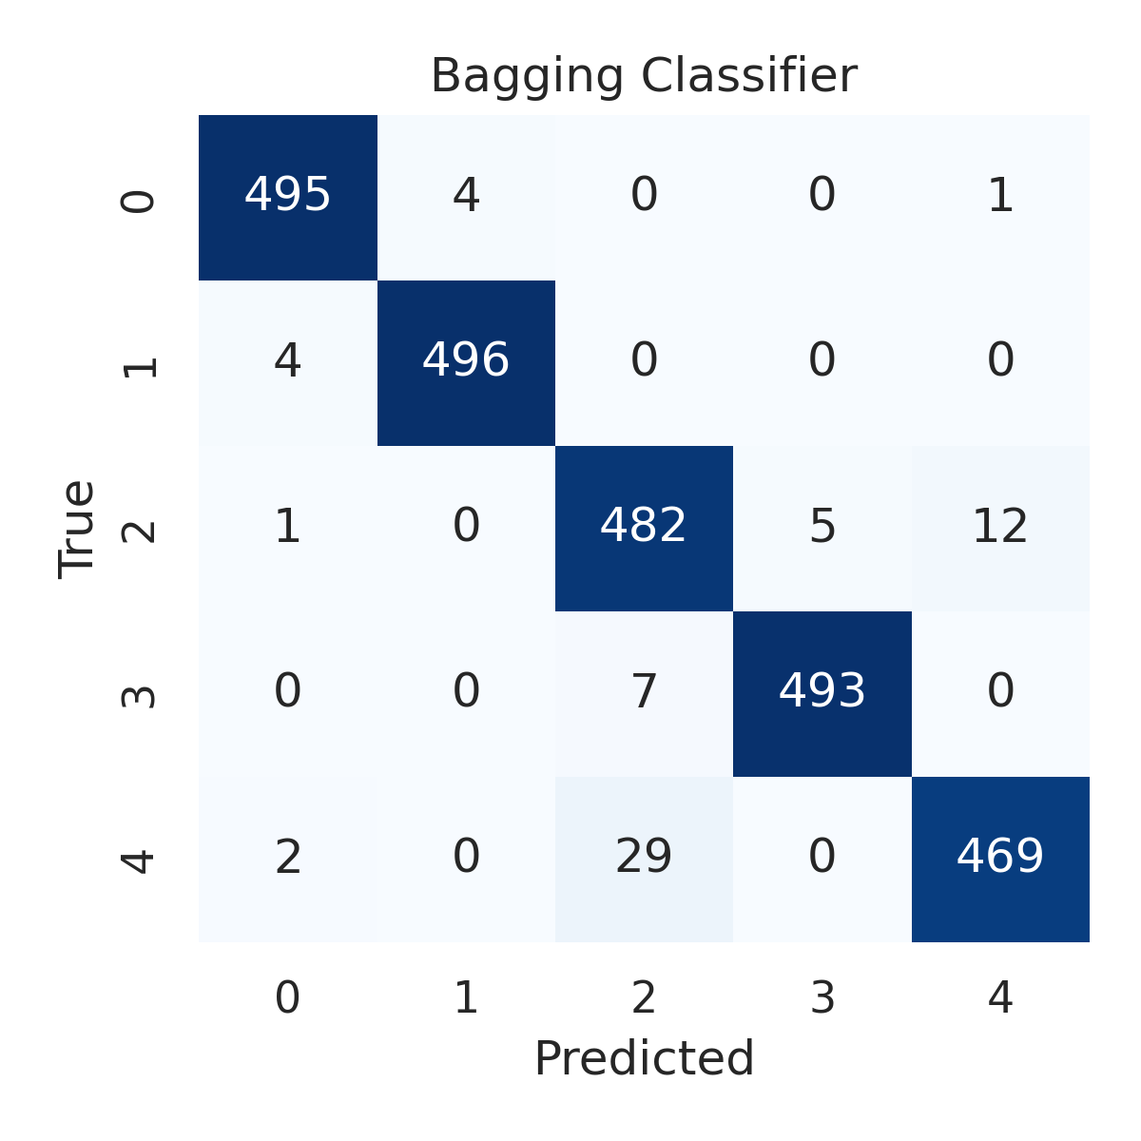

Combined ROC Curves
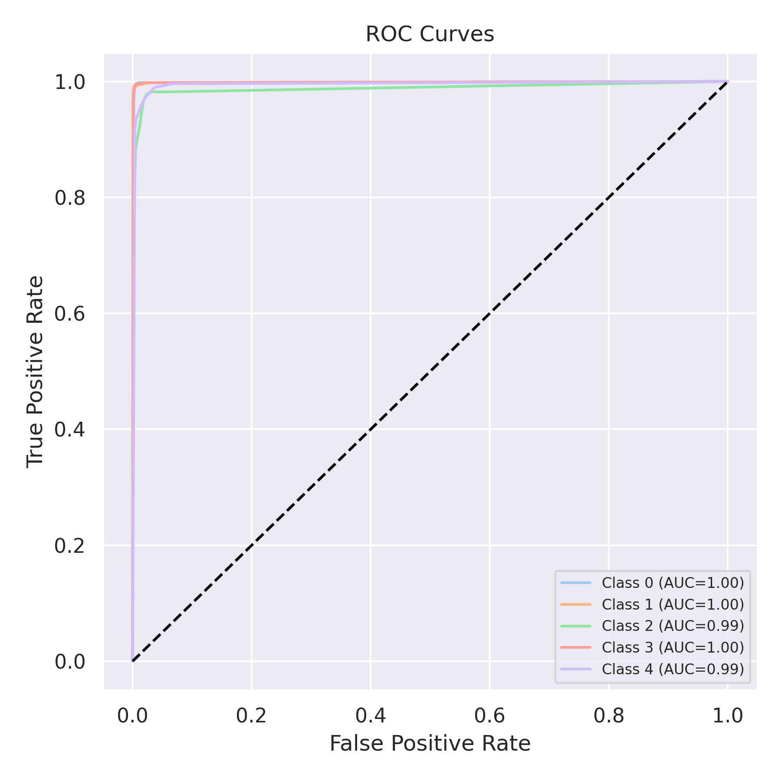

Evaluation: XGBoost
Accuracy: 0.9808
Precision: 0.980812942385303
Recall: 0.9808
F1 Score: 0.9807881606718509
Jaccard Index: 0.9626821986493871
Matthews CorrCoef: 0.9760091745293611
Cohen’s Kappa: 0.976
Specificity: 0.9952
AUC: 0.9991709999999999
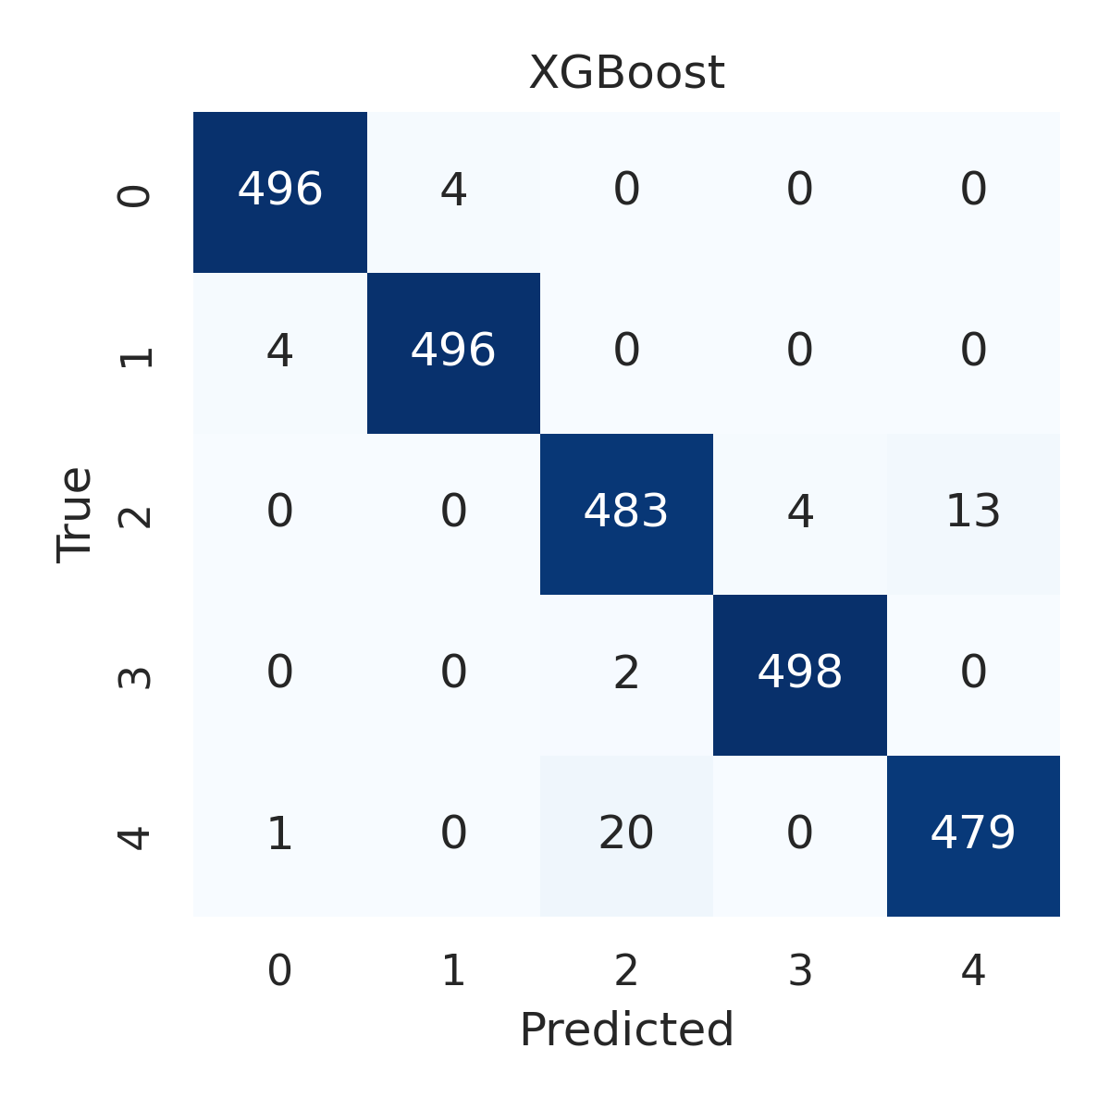

Combined ROC Curves
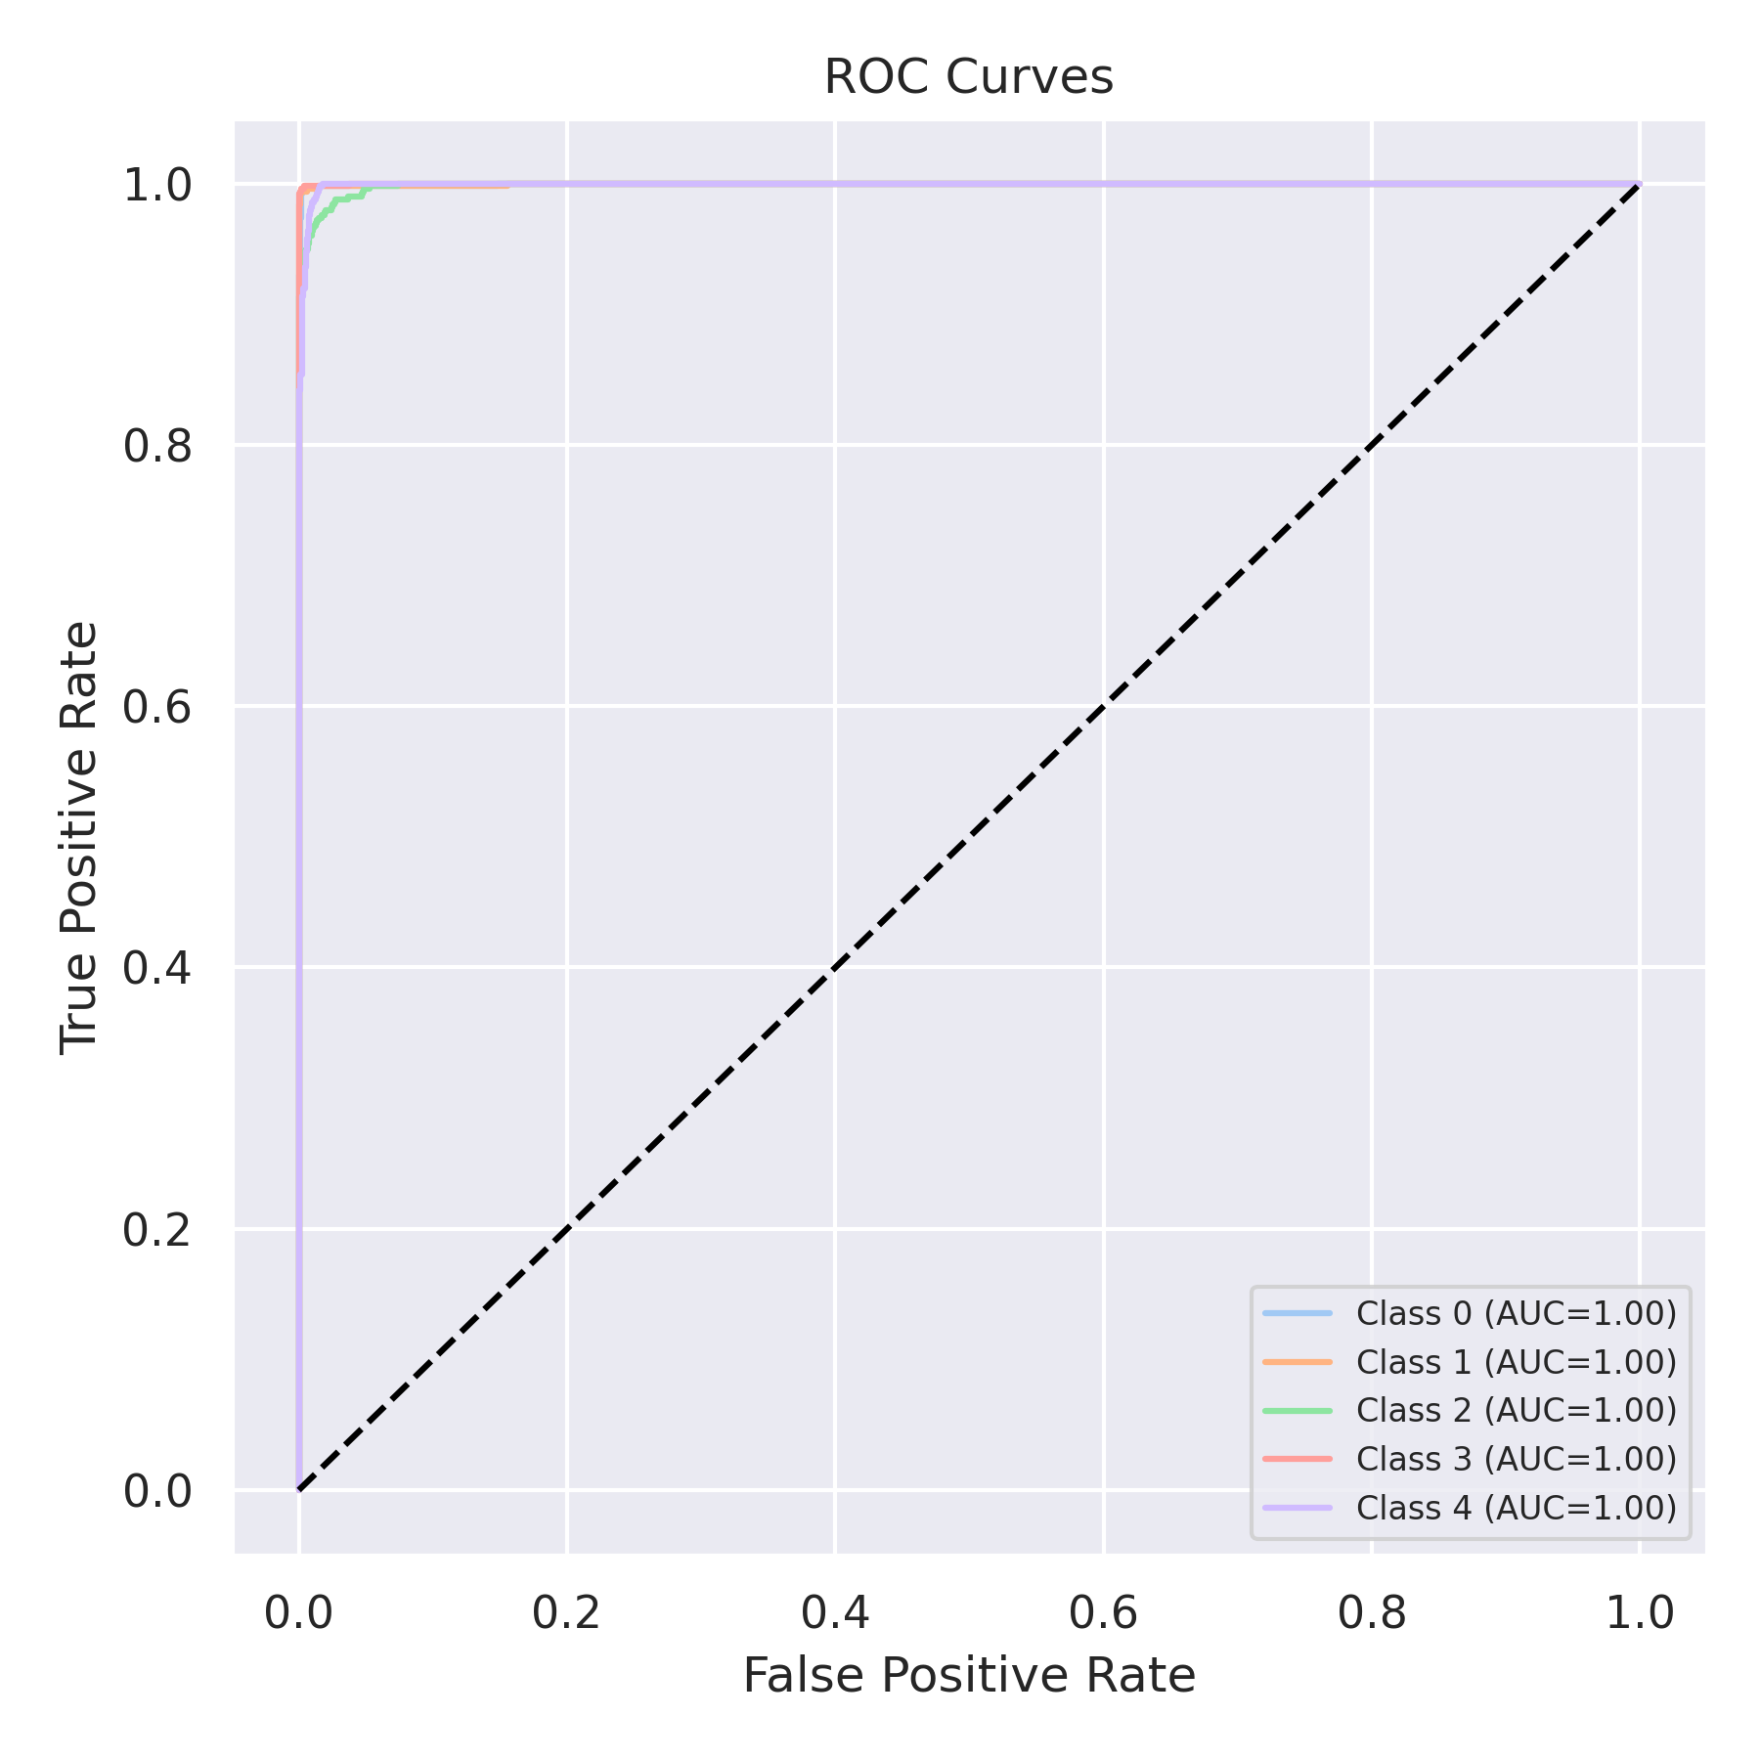

Evaluation: LightGBM
Accuracy: 0.9804
Precision: 0.9804280997637943
Recall: 0.9804
F1 Score: 0.9803800160863422
Jaccard Index: 0.9619720716504169
Matthews CorrCoef: 0.9755169741430264
Cohen’s Kappa: 0.9755
Specificity: 0.9951000000000001
AUC: 0.999301
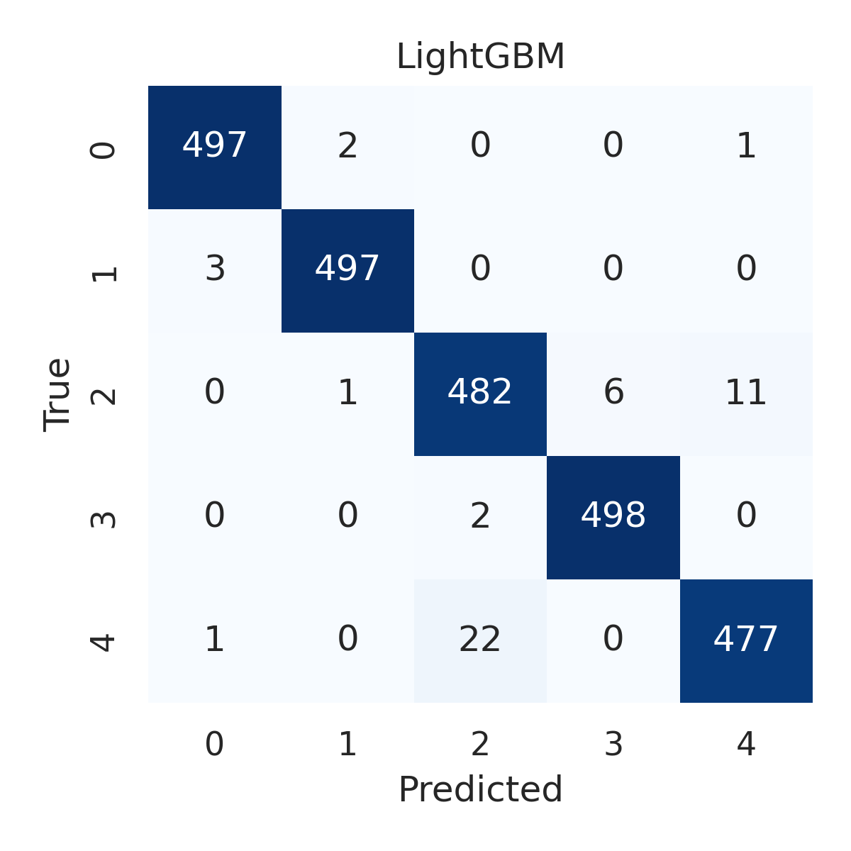

Combined ROC Curves
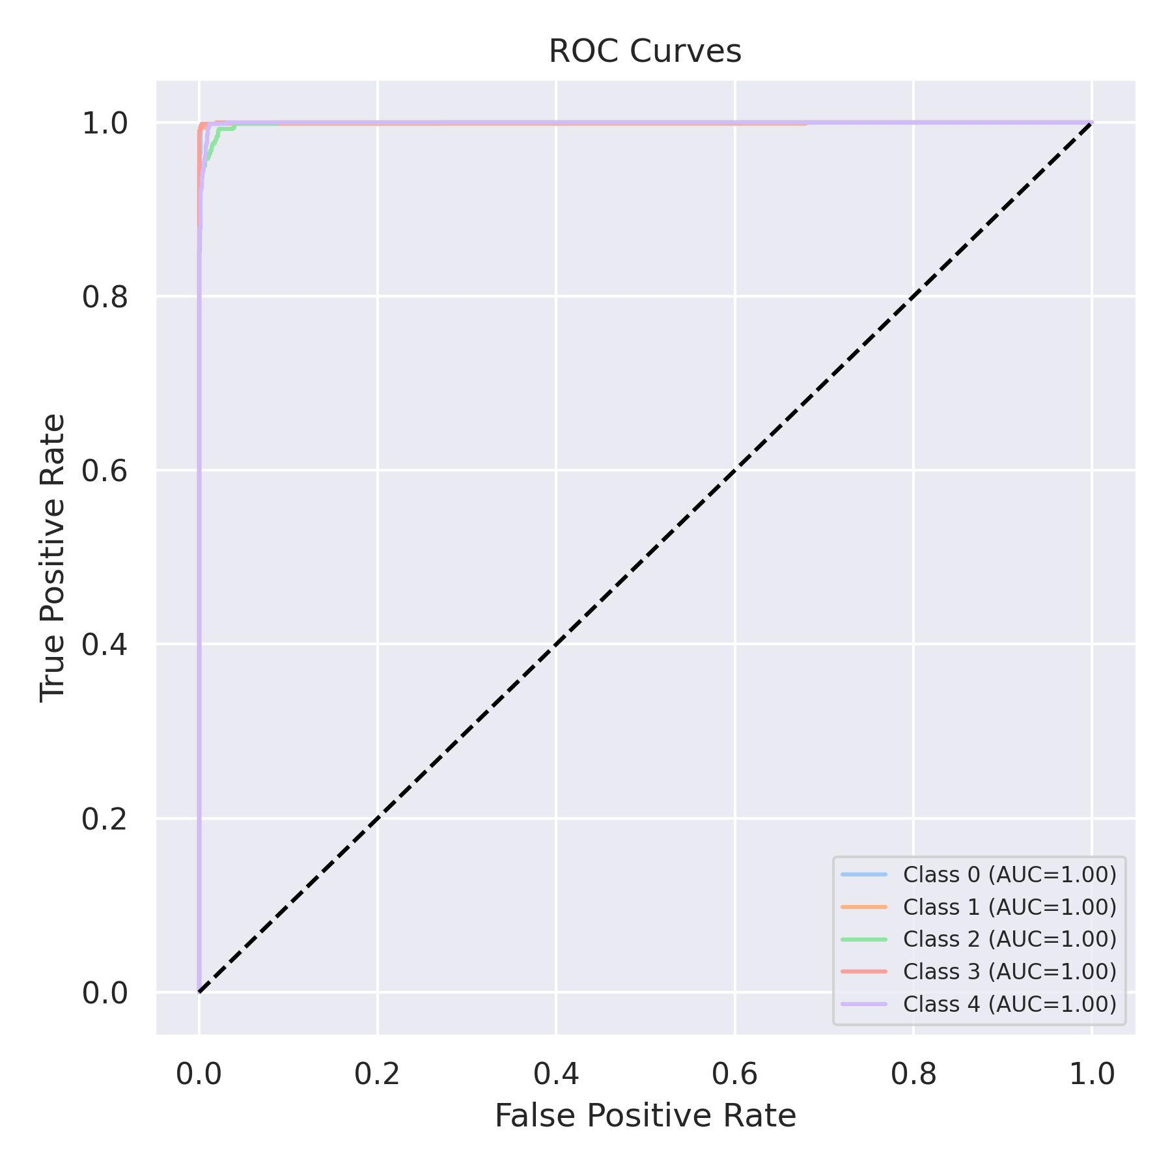

Evaluation: CatBoost
Accuracy: 0.2
Precision: 0.04
Recall: 0.2
F1 Score: 0.06666666666666667
Jaccard Index: 0.04
Matthews CorrCoef: 0.0
Cohen’s Kappa: 0.0
Specificity: 0.8
AUC: 0.9991309999999999
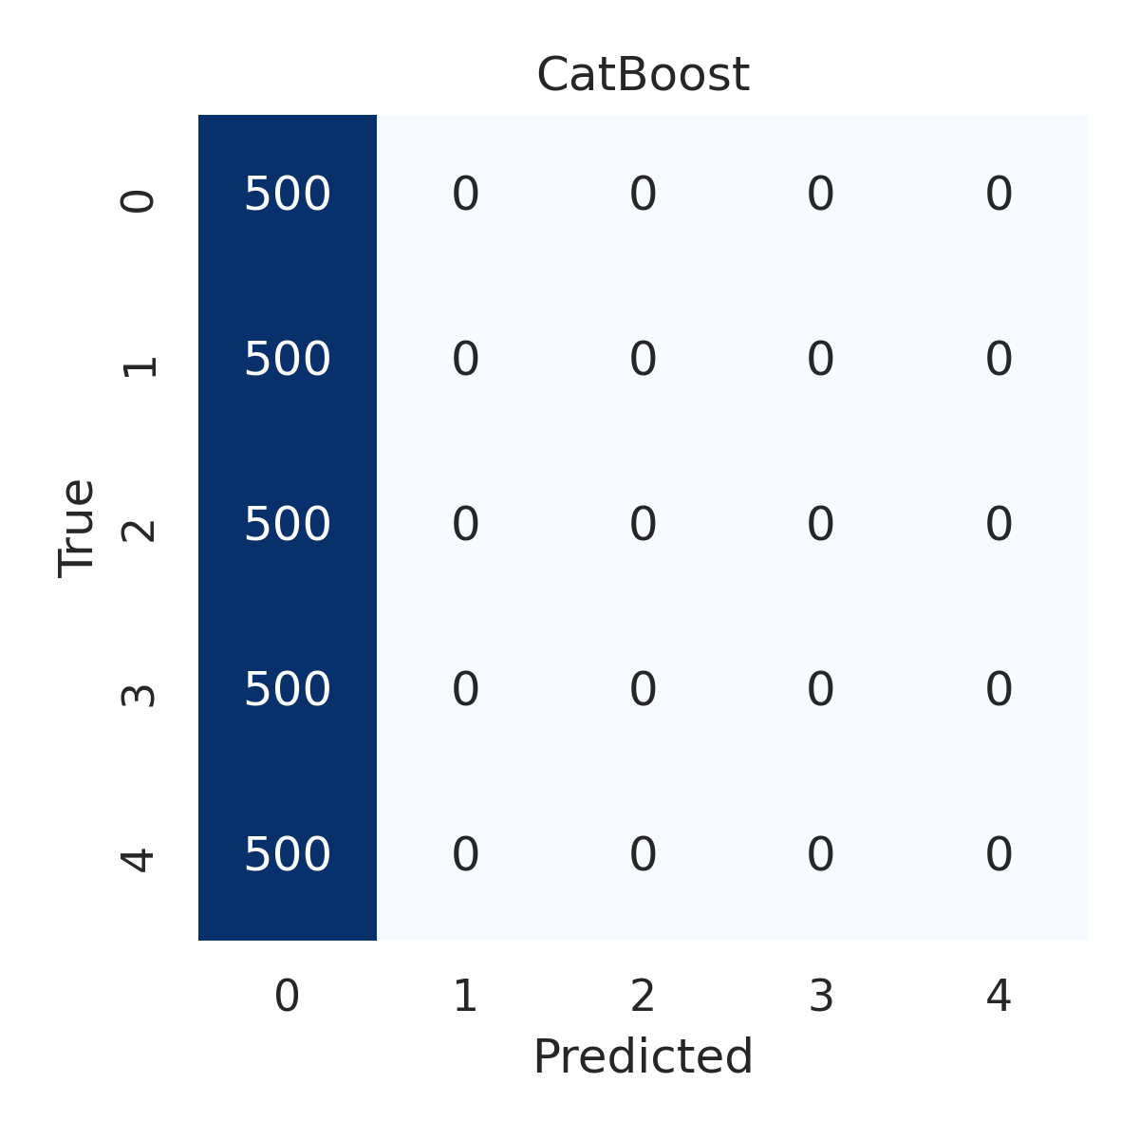

Combined ROC Curves
